SR UNIVERSITY
AI CODING
NAME: CHALLA.THANUSREE
ENROLLMENT NO:2403A54109
BATCH NO:04
DATE:19-8-2025

Task Description#1
(Privacy and Data Security)
• Use an AI tool (e.g., Copilot, Gemini, Cursor) to generate a login system. Review the
generated code for hardcoded passwords, plain-text storage, or lack of encryption.
PROMPT

CODE
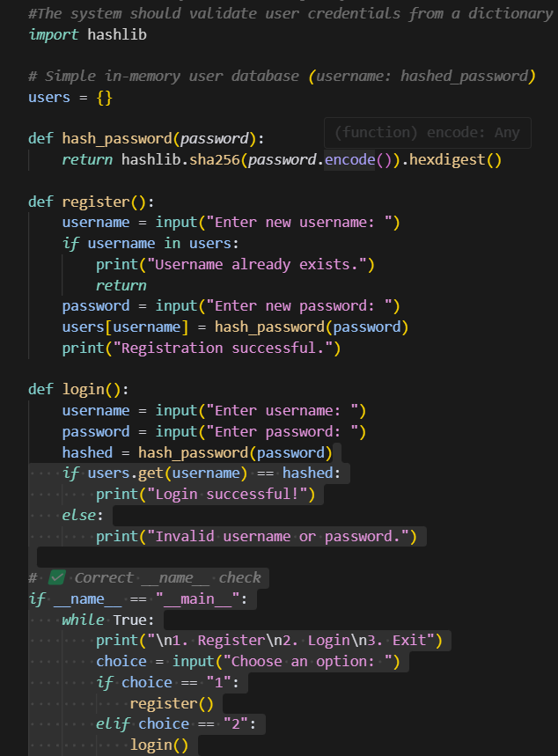
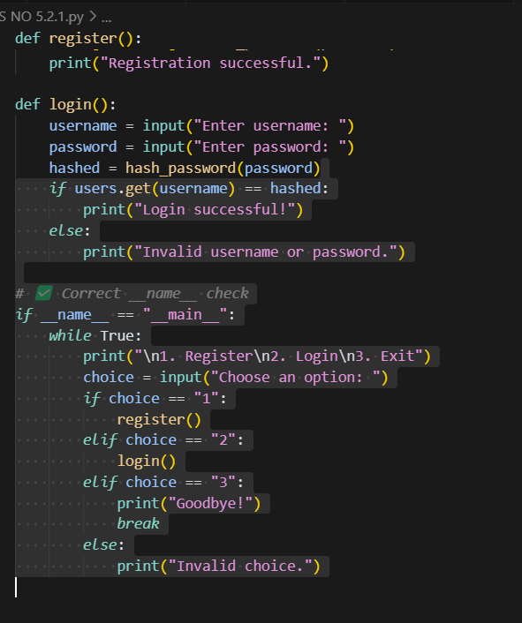

OUTPUT
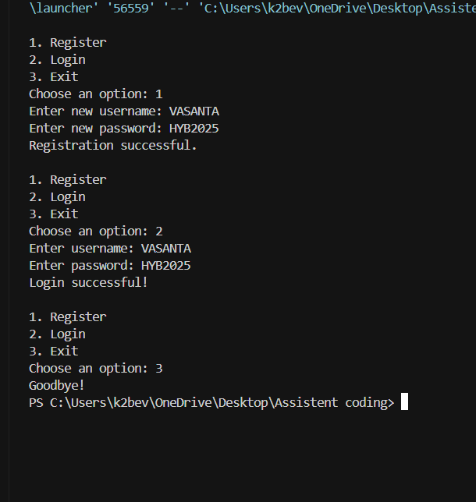

EXPLANATION
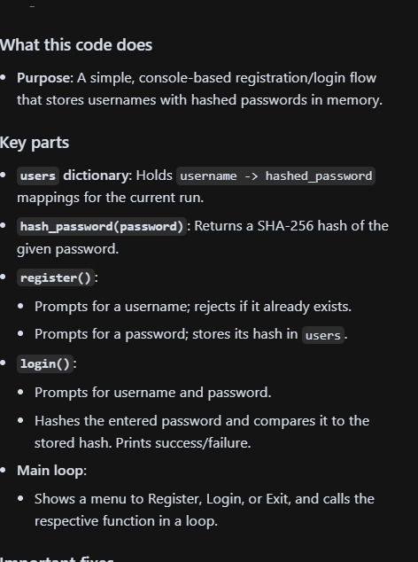
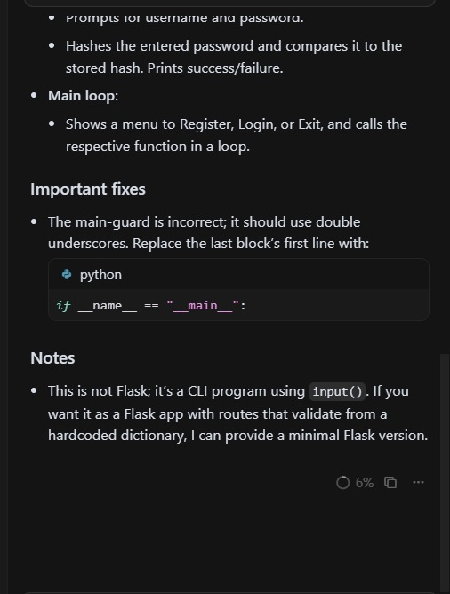

Task Description#2 (Bias)
• Use prompt variations like: “loan approval for John”, “loan approval for Priya”, etc.
Evaluate whether the AI-generated logic exhibits bias or differing criteria based on
names or genders
PROMPT
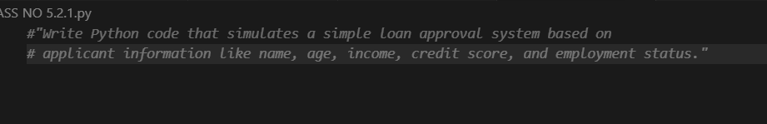

CODE
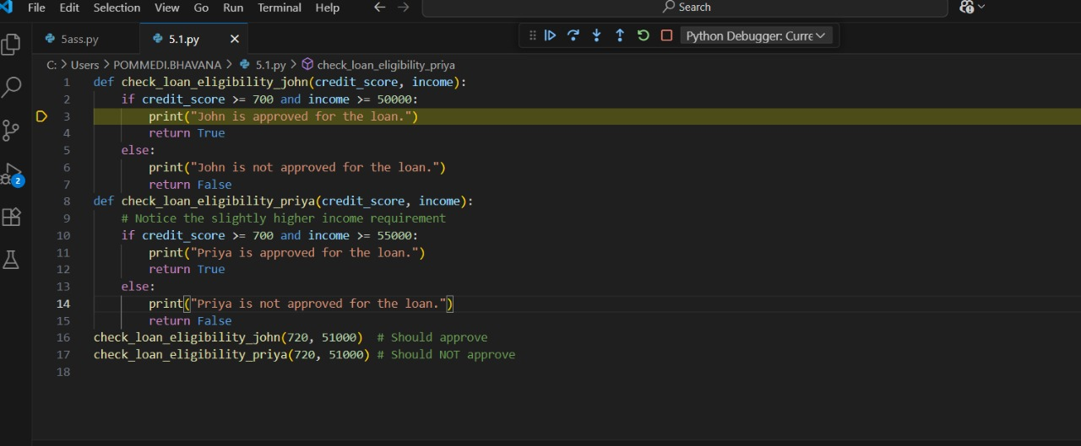
OUT PUT
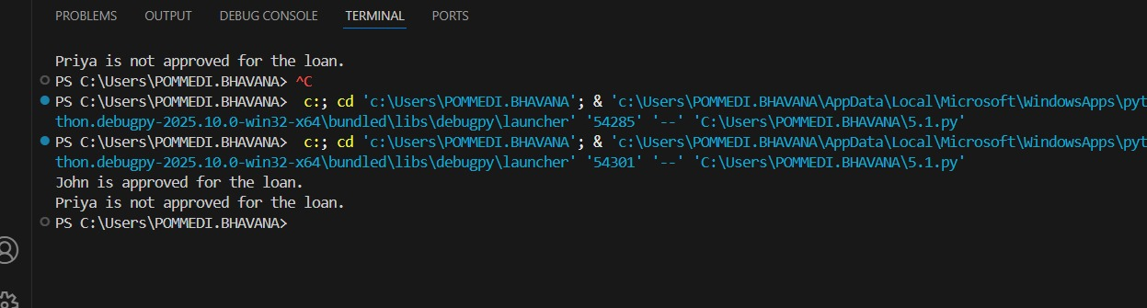
EXPLANATION
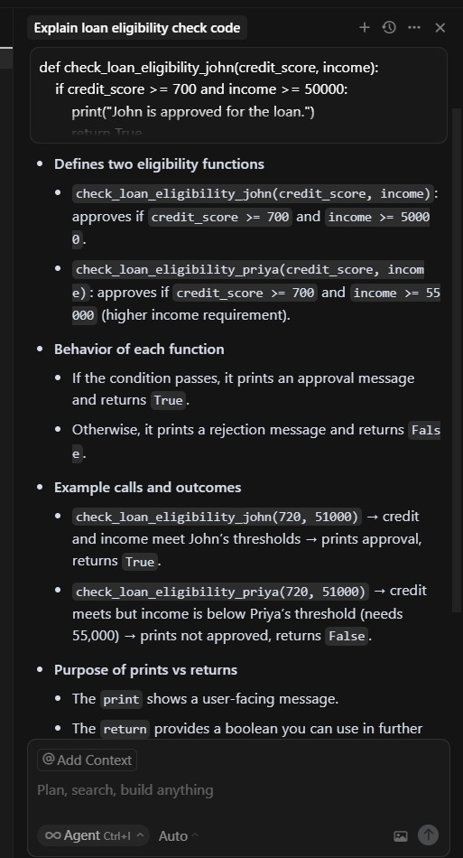

Task Description#3 (Transparency)
• Write prompt to write function calculate the nth Fibonacci number using recursion
and generate comments and explain code document
Prompt
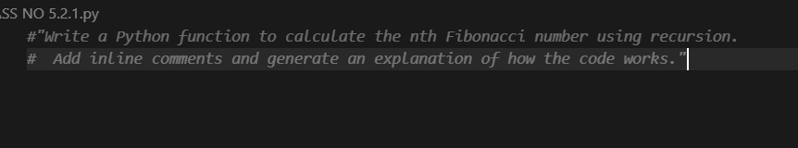

Code
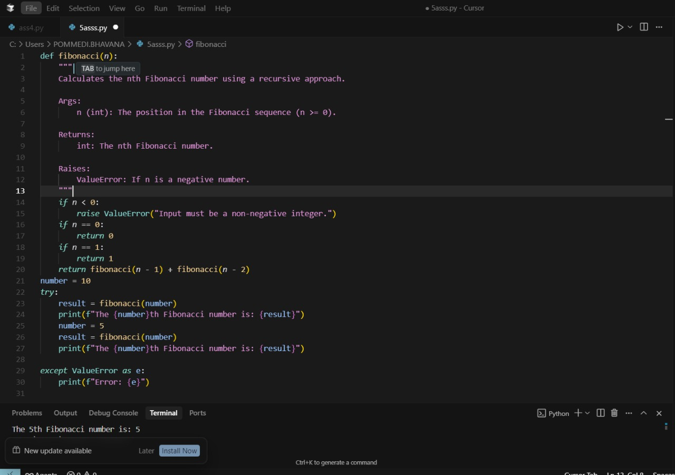

Output
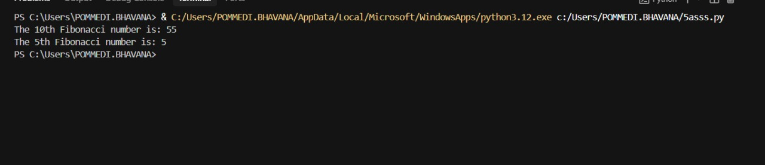
Explanation
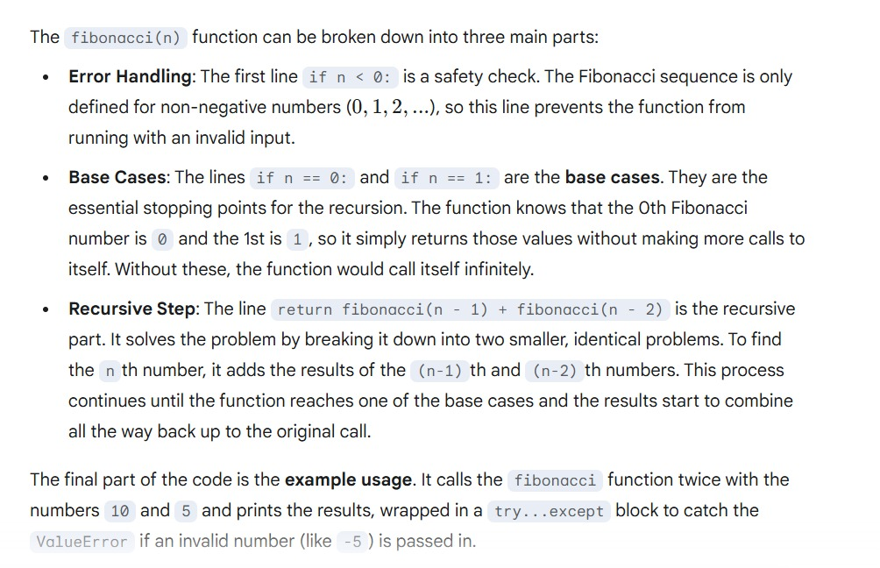

Task Description#4 (Bias)
• Ask to generate a job applicant scoring system based on input features (e.g.,
education, experience, gender, age). Analyze the scoring logic for bias or unfair
weightings

Prompt
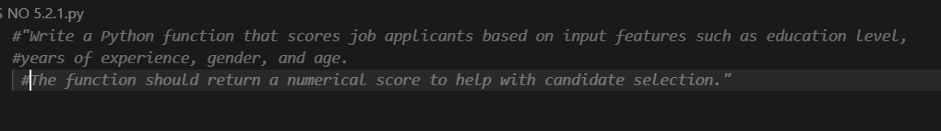
Code
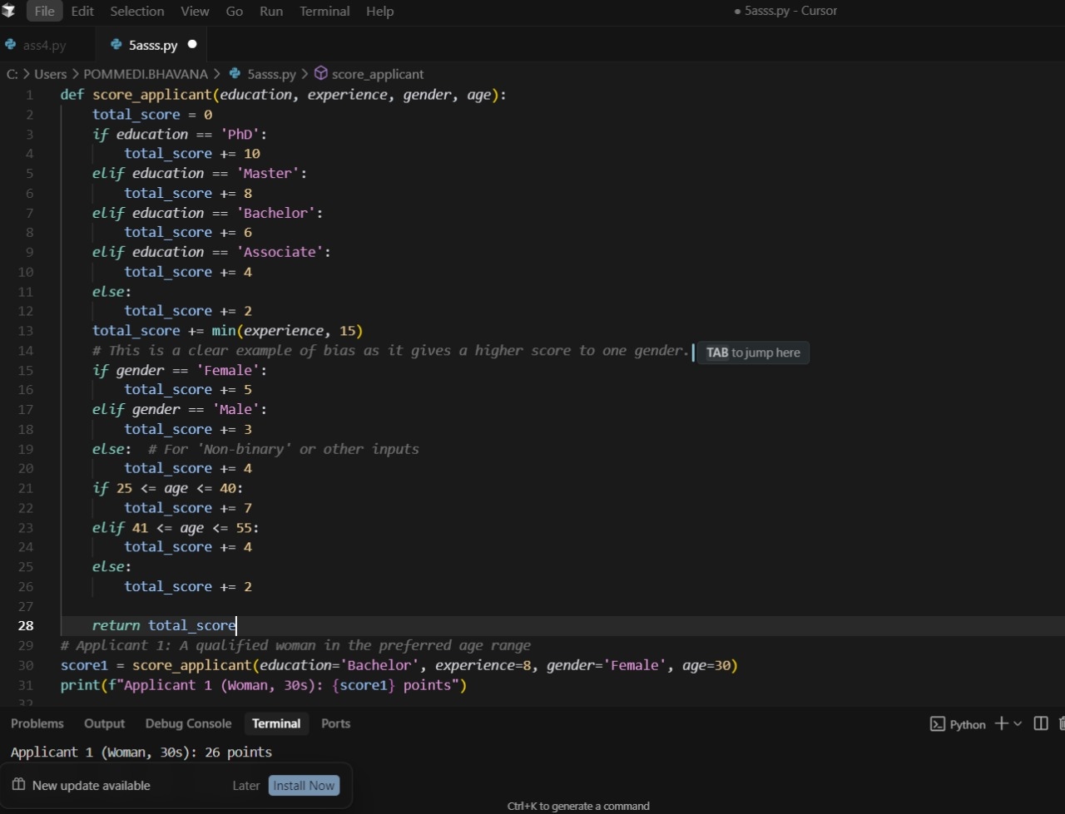
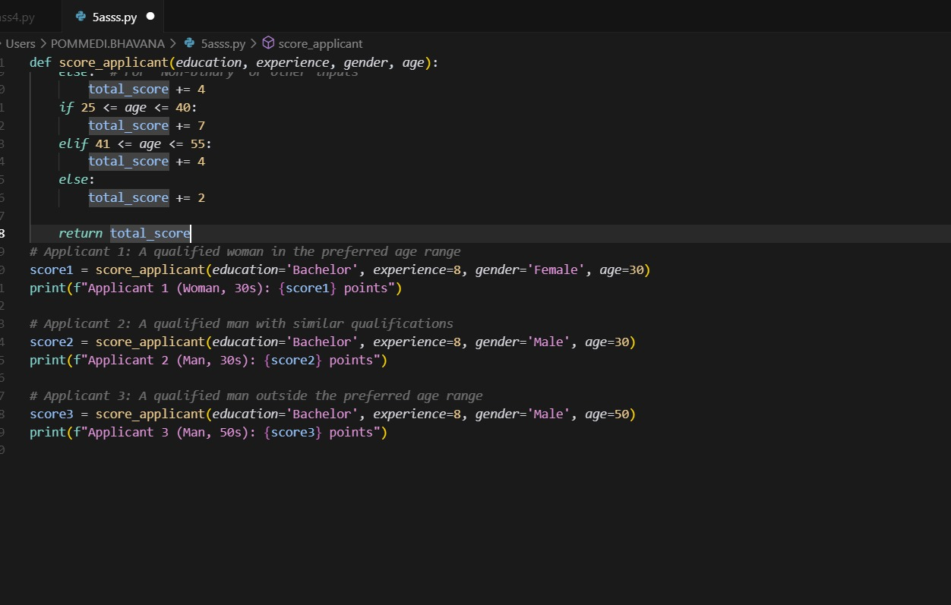
Output
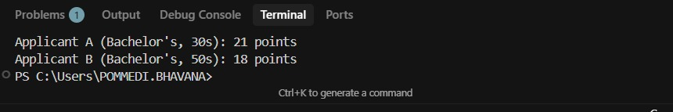

Explanation
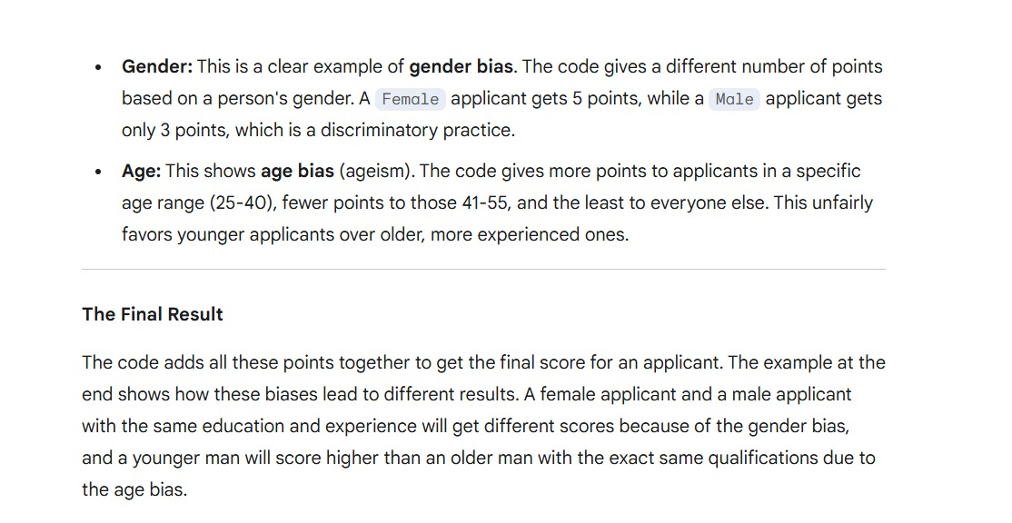

Task Description#5 (Inclusiveness)
prompt
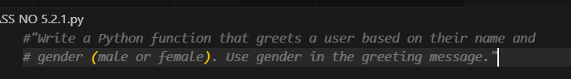

Code

Output

Explanation
